**Jac-Cen-Del Community Schools**

**Central Office High School / Athletics Elementary School**

723 N Buckeye Street 4586 N US 421 4544 N US 421

Osgood, Indiana 47037 Osgood, Indiana 47037 Osgood, Indiana 47037

Telephone: (812) 689-4114 Telephone: (812) 689-4643 Telephone: (812) 689-4144

Fax: (812) 689-7423 Fax: (812) 689-5632 Fax: (812) 689-5909

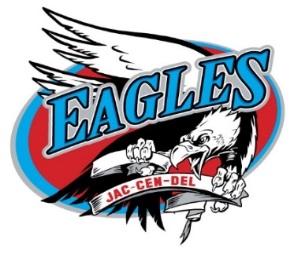

[www.jaccendel.k12.in.us](http://www.jaccendel.k12.in.us)

• Every Child • Every Chance • Every Day •

**Open Position:** Head Girls Volleyball Coach

**Application:** Please send letter of interest and resume to Athletic Director Paul Stone

[pstone@jcdapps.com](mailto:pstone@jcdapps.com)

**Application deadline:** Until Filled

**Description:** Jac-Cen-Del is accepting applications for its Varsity Girls Volleyball Coach.

**Qualifications:**

1. Ability to organize and oversee all aspects of a successful volleyball program.
2. Extensive knowledge on the overall game of volleyball.
3. Knowledge of proper training and conditioning techniques and ability to effectively articulate and implement said techniques.
4. Strong organization, leadership and communication skills with the ability to form relationships within the school community and work cooperatively with others.
5. Ability to adapt defensive and offensive schemes based on personnel.
6. Ability to relate with and manage student-athletes.
7. Ability to plan one fundraising event.
8. Must successfully complete background screening.

**Duties and Responsibilities:**

1. Oversee all aspects of running an entire volleyball program.
2. Recruitment and vetting of qualified assistant coaches.
3. Delegate specific coaching duties to assistant coaches while promoting positive working relationships and supervise implementation of said duties.
4. Be a positive role model and exhibit model conduct and appearance on and off the court.
5. Communicate expectations, future plans, schedules, events, etc. with players and parents.
6. Monitor the academic progress of all players within the Girls volleyball Program.
7. Ensure the student-athlete has a well-rounded experience including enforcing discipline while helping our student-athletes learn necessities of life outside the realm of volleyball.
8. Assist student-athletes in playing at the next level. Make connections with college coaches and explain the process of eligibility and recruiting to players and parents.
9. Work collaboratively with fellow coaches at Herron High School to encourage student-athletes to participate in multiple sports.
10. Responsible for maintaining good public relations with news media, booster club, parents, community, fans, administration and co-workers.
11. Adhere to all school, conference and IHSAA policies and procedures.
12. Ensure that all website and social media information is up to date and accurate while maintaining accurate stats, records and results and dispersing them accordingly (MaxPreps, IndyStar, etc.)
13. Organize preseason parent meeting.
14. Maintain uniform inventories and submit to Athletic Director at the end of each season.
15. Coordinate with Athletic Director and document all post season items including but not limited to: post season awards, changes to schedule, assistant coaches meeting and individual player meetings.